Knowledge Organiser
MUSIC | Recorder Course YEAR 3 SPRING 1
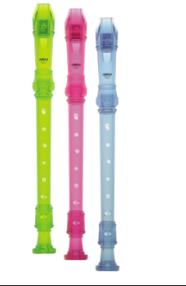 | The Recorder is a woodwind musical instrument in the group known as internal duct flutes- flutes with a whistle mouthpiece, also known as fipple flute. A recorder can be distinguished from other duct flutes by the presence of a thumb-hole for the upper hand and seven finger-holes. Recorders are made in different sizes with names and compasses roughly corresponding to different vocal ranges. The sizes most commonly used are soprano (aka descant), alto ( aka treble), tenor and bass.
Origins and Traditions
- The recorder is first documented in Europe in the Middle Ages and continued to enjoy popularity in the Renaissance and Baroque but was little used in the Classical and Romantic periods.
- Revived in the 20th Century and became a popular amateur & educational instrument.
- Composers who have written for recorders are Monteverdi, Lully Purcell, Handel, Vivaldi, Telemann, Johann Sebastian Bach, Paul Hindemith, Benjamin Britten, Leonard Bernstein, Luciano Berio, Arvo Part.

Related Instruments
Aerophone Irish Tin Whistle Flageolet Three hole- pipe
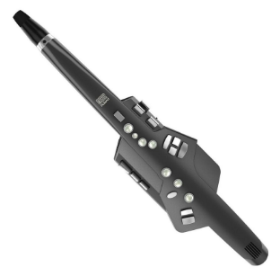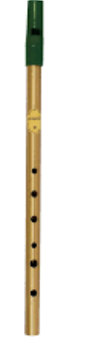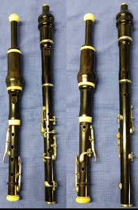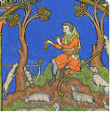

Key Vocabulary
Playing position- the recorder is held with both hands covering the finger holes or depressing the keys with the pads of the fingers.
Pitch-the degree of highness or lowness of a note.
Forked fingerings-is a fingering in which an open hole has covered holes below it: fingerings for which the uncovering of the hole is not sequential.
Aerophone-any musical instrument that produces sound primarily by causing a body of air to vibrate, without the use of strings or membranes, and without the vibration of the instrument itself adding considerably to the sound.
Tin Whistle-a small flute-like instrument made from a thin metal tube, with six finger holes of varying size on top and no thumb holes.
Flageolet-a very small wind instrument resembling a recorder but with four finger holes on top and two thumb holes below.

Master Recorder players
Ferdinand Conrad, Kees Otten, Frans Bruggen, Roger Cotte, Hans-Martin Linde, Bernard Krainis, David Munrow

Useful websites
www.srp.org.uk/useful-links/

