Knowledge Organiser
Music | EYFS Spring 2
This half termly (6-step) focus-based approach supports teachers in engaging all young children with music. It includes a variety of adult-led and child-initiated activities delivered through planning and play. All the musical learning is focussed around nursery rhymes and action songs.
Focus pieces
Lovely day-Bill Withers Frogs legs and Dragons teeth- Bellowhead
Beyond the sea- Robbie Williams Ain’t no Mountain high enough- Marvin Gaye & Tammi
Mars from The Planets- Gustav Holst Terrell
Singing in the Rain- Gene Kelly
Artists
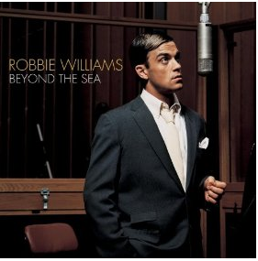  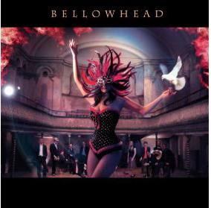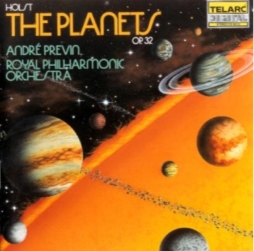 | 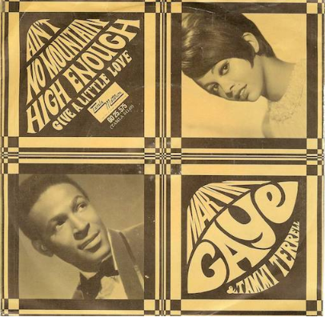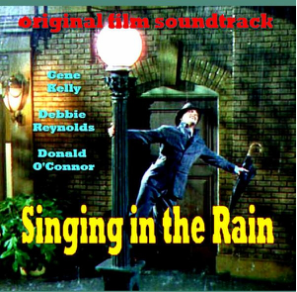
Other pieces of music we will be studying
Old Macdonald had a farm  Incy Wincy spider  The Wheels on the Bus | Baa Baa black sheep  Row, row, row your boat  The Hokey Cokey
Musical learning focus
Listen and Respond. Explore and Create - initially using voices only but building to using classroom instruments too. Singing - nursery rhymes and action songs - building to singing and playing. Share and Perform.

Key Vocabulary
Pulse - steady beat -The foundation of all music, it is a musical heartbeat that never stops.
Rhythm - The long and short sounds that happen over the pulse (steady beat) so, rhythm changes and pulse stays the same.
Pitch - high and low sounds
Sources of planning
National Curriculum, Charanga

