Knowledge Organiser
History: The American Civil War |  | Year 6 AUTUMN TERM
The American Civil War was a civil war in the United States from 1861 to 1865, fought between northern states loyal to the Union and southern states that had seceded to form the Confederate States of America. The civil war began primarily as a result of the long-standing controversy over the enslavement of black people
Enquiry Questions
Question 1  Why did the United States rapidly expand after the American war of Independence? | Answer:  The united states expanded drastically in the decades after the American war of Independence. This was due to a range of factors though the main ones are the belief in Manifest Destiny, purchases of land from other global powers and conquest
Question 2  How was slavery involved in the American Civil War? | Answer:  Slavery played the central role during the American Civil War. The primary catalyst for secession was slavery, especially Southern political leaders' resistance to attempts by Northern antislavery political forces to block the expansion of slavery into the western territories.
Question 3  What role did Abraham Lincoln play in the American Civil War? | Answer:  Abraham Lincoln was an American statesman and lawyer who served as the 16th president of the United States from 1861 to 1865. He led the nation through its greatest moral, constitutional, and political crisis during the American Civil War and managed to abolish slavery.
Question 4  What was different between the two sides in the American Civil War? | Answer:  The northern states, who remained part of the Union were largely more industrialised and better equipped than their southern counterparts. The southern states, largely being home to farming communities, were less advanced but fought hard.
Question 5  What were the consequences of the American Civil War? | Answer:  By the end of the war in 1865 the country had gone through a number of changes. Slavery was abolished, the union was preserved and the control of government was made stronger as a result. The human cost of the war was vast with more than 1,000,000 dead and the racial problems which had been a catalyst for the conflict were intensified as racial prejudice was pushed underground leading to the establishment of groups like the Ku Klux Klan.
Famous People
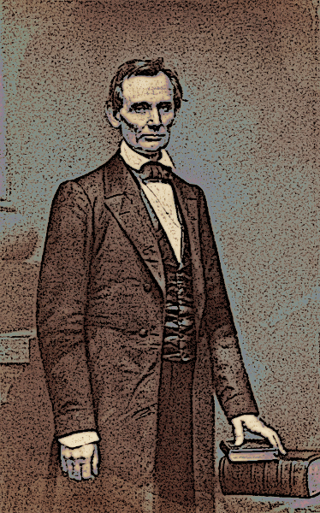  Abraham Lincoln | 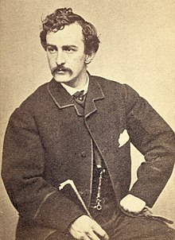  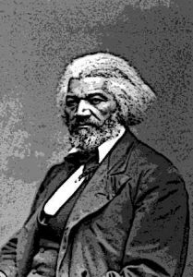  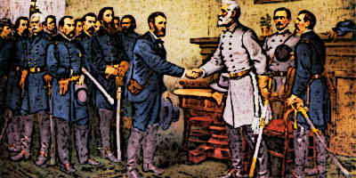  Frederick Douglass  John Wilkes Booth  Robert E. Lee

Timeline
 | February 09, 1861 | Confederation was formed  At a convention in Montgomery, Alabama, the seven seceding states created the Confederate Constitution, a document similar to the United States Constitution, but with greater stress on the autonomy of each state. Jefferson Davis was named the president of the Confederacy until elections could be held.
 | March 1861 | Lincoln Inaugurated  Abraham Lincoln was inaugurated on March 4th. The new president said he had no plans to end slavery in those states where it already existed, but he also said he would not accept secession. He hoped to resolve the national crisis without warfare.
 | April 1861 | Attack on Ft. Sumter  When President Lincoln planned to send supplies to Fort Sumter, he alerted the state in advance, in an attempt to avoid hostilities. South Carolina, however, feared a trick and the commander of the fort, Robert Anderson, was asked to surrender immediately. Anderson offered to surrender, but only after he had exhausted his supplies. His offer was rejected, and on April 12, the Civil War began with shots fired on the fort. Fort Sumter eventually was surrendered to South Carolina.
 | July 1861 | First Battle of Bull Run  This was one of many battles where many soldiers from both sides were wounded and killed. General Irvin McDowell was ordered to advance on Confederate troops stationed in Virginia. McDowell attacked on July 21, and was successful at first, but the introduction of Confederate reinforcements resulted in a Southern victory. Lincoln replaced McDowell with General George B. McClellan.
 | January 1862 | Many Battles  Some of the major battles include the First and Second Battles of Bull Run, The Battle of Shiloh, The Battle of Antietam, and the Battle of Fredericksburg. There was also the famous sea battle between the two ironclad battleships the Monitor and the Merrimac. These ships had iron or steel plates on their sides for armour making them much stronger and changing war on the seas forever.
 | January 01, 1863 | Emancipation Proclamation  President Lincoln issues an executive order freeing many slaves and laying the groundwork for the Thirteenth Amendment.
 | July 01, 1863 | Battle of Gettysburg  This was a major battle where the North not only wins the battle, but starts to win the Civil War.
 | September 02, 1864 | Sherman captures Atlanta  General Sherman captures the city of Atlanta, Georgia. Later in the year he would march to the sea and capture Savannah, Georgia. On his way he would destroy and burn much of the land his army passed through.
 | April 04, 1865 | General Lee Surrenders  General Lee, the leader of the Confederate Army, surrenders to General Ulysses S. Grant at The Appomattox Court House in Virginia.
 | April 14, 1865 | Lincoln Assassinated  While attending the Ford's Theatre, President Lincoln is shot and killed by John Wilkes Booth.

Key Vocabulary
Manifest Destiny | The 19th-century doctrine or belief that the expansion of the United States throughout the American continent could not be stopped.
Conquest | The subjugation and assumption of control of a place or people by military force.
Union | The Union was a name used to refer to the federal government of the United States, which was supported by the 20 free states and five border slave states.
Confederacy | The 11 southern states which relied on slavery that declared a secession from the Union.
Johnny Reb | Johnny Reb is the national personification of the common soldier of the Confederacy
Yankee | Yankee was a term used by Southerners to describe their rivals from the Union, or northern, side of the conflict.
Slavery | Slavery and enslavement are the state and condition of being a slave. A person is enslaved when a slaver coerces him or her into working for them and is deprived of the opportunity to leave.
Succession | Succession is the withdrawal of one group from a larger group. The Civil War begun in America when the southern states succeed from the Union because they disagreed with the abolition of slavery, rights and new laws.

