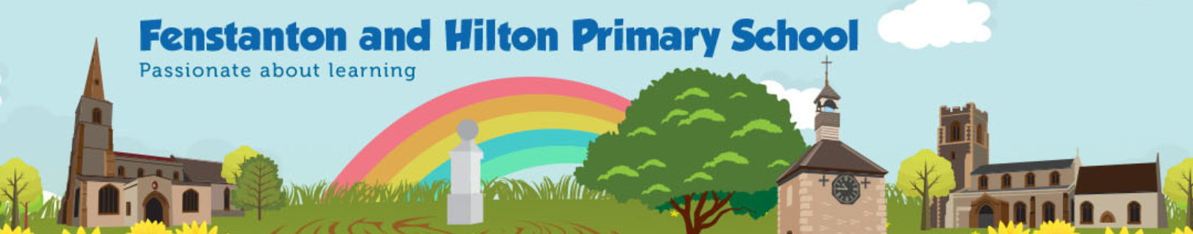
Knowledge Organiser
Science: Physics - Light |  | 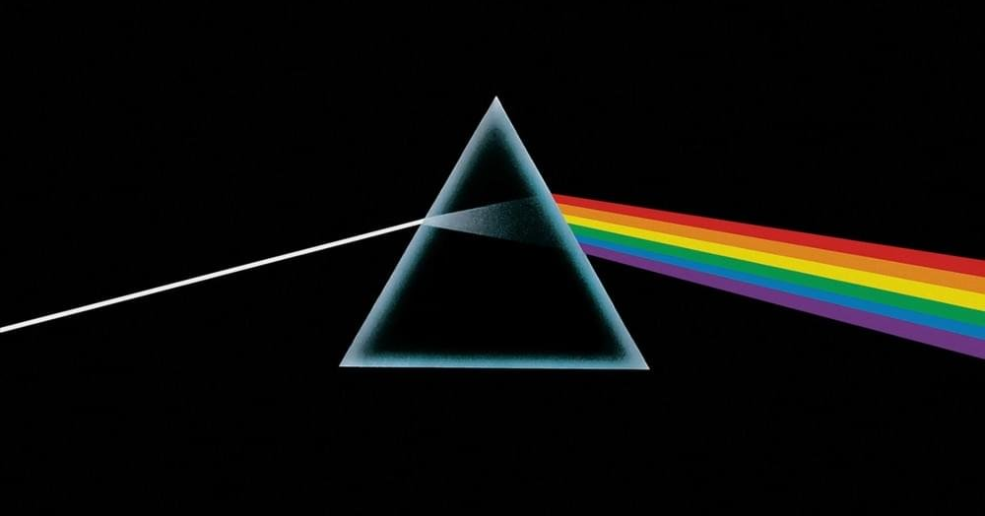  Year 6 AUTUMN TERM
Light or visible light is electromagnetic radiation within the portion of the electromagnetic spectrum that can be perceived by the human eye.
Enquiry Questions
Question 1  What is Light? | Answer:  Light, electromagnetic radiation that can be detected by the human eye.
Question 2  How does light travel? | Answer:  Light travels as waves. These are transverse waves, like the ripples in a tank of water.
Question 3  How does reflection help us see? | Answer:  Reflection is how we use light to see around us. Reflection is when light hits the surface of an object and then that light travels to our eyes so we can see. Objects such as tables and chair reflect an image of the object itself so we can see it.
Question 4  Why do objects look bent when viewed through a glass filled with water? | Answer:  When light passes through objects is refracted. This is because the waves of light are being slowed down and their path is altered by the substance they are passing through.
Question 5  What makes a material reflective? | Answer:  Normally, lighter and polished materials are more reflective than darker ones. This is because darker materials absorb light waves.
Fun Facts
- Light can travel through some types of matter, but not others. Light travels through air. It can be seen through a glass window or a sheet of clear plastic wrap. These types of matter are transparent. Some objects are translucent, meaning that some light passes through them, while some light is reflected. Wax paper is a good example. Opaque matter reflects light, or bounces it back into the environment. Your book, your pants, or your blanket are all opaque. No light goes through them.
- Light is a form of energy, and a pretty important one. Without light, life on our planet would die. Sunlight warms our planet and helps plants grow. People and animals need sunlight to help produce vitamin D in their bodies. Light is not considered matter, but is made of photons.
- Light travels faster than anything else in the universe. In a vacuum, it travels at a speed of 186,282 miles per second.
- Light usually travels on a straight path, but it bends – or refracts – when traveling through a transparent object. A prism is a good example of refracted light. Place a metal spoon in a transparent glass filled with water. The spoon appears to be bent because of how the light moves through the glass.
- Have you heard the word luminous? A source that gives out their own light are classed as luminous. Examples of luminous sources are: The Sun – TV’s – Candles – Light bulb – Fireworks.
- Magnifying glass refracts light giving an enlarged view of objects.
- A rainbow is a spectrum, this spectrum is seen when sunlight passes through rain or water drops.

Key Vocabulary
Light source | An object which emits waves of light.
Reflect | In Physics it is the change in direction of a wavefront at an interface of two different media. Or the change in direction of a wavefront when it comes into contact with a reflective surface.
Refraction | In physics, refraction is the change in direction of a wave passing from one medium to another
Medium | In Physics: A substance that makes possible the transfer of energy from one location to another
Vacuum | A vacuum is space with no matter in it. The word stems from the Latin adjective vacuus for "vacant" or "void".
Transvers wave | A wave in which the medium vibrates at right angles to the direction of its propagation.

