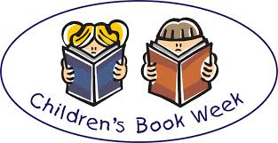
Book week – Reading challenge homework
Dear Parents,
As it is Book Week next week, we would like the children to focus on reading for their homework this week and next . Please can you encourage your child to complete as many of these activities as possible during the next two weeks and colour in a square when they have done so. You may also comment on how they get on if you wish. Please can the children bring back their chart in on Monday 21st March. Thank you for your support.
I read a story to a member of my family | I read a poem | I read a picture book | I recommended a book to someone else and explained why I thought they’d like it. | I read 5 street signs / shop signs
I read a non- fiction book | I listened whilst someone read a story to me. | I looked at a map and found out some information from it. | I read some jokes | I researched an author
I read and followed a recipe | I read the back of a cereal packet | I read a magazine / comic | I wrote a poem on a subject I’m interested about. | I listened to a story online.  http://worldbookday.com/storytime-online/
I read the TV listings for the day and could say what time things were on. | I borrowed a book from the library / bought a new book to read ( remember you can use your £1 book token) | I designed a comic strip | I read a  Leaflet and could explain what it was about. | I read and followed some instructions e.g. how to play a game.

