Knowledge Organiser
MUSIC | Year 3 Spring 2- Playing with sound
Wolfgang Amadeus Mozart was born on January 27th, 1756, in Salzburg, Austria. Mozart was a musician capable of playing multiple instruments who started playing in public at the age of 6. Someone who writes music is called a composer. He composed many operas and symphonies in his lifetime including The Magic Flute, The Marriage of Figaro and Don Giovanii.  He composed more than 600 works in his lifetime.  His operas were often performed at the peoples’ opera, and everyone came to see them. He married Constanzein August 1782 and they had six children,Raimund, Karl, Johann, Theresia, Anna Maria and Franz only 2 of whom survived infancy. He died at the age of 35 in Vienna in December 1791 and was buried in a paupers grave. | 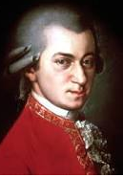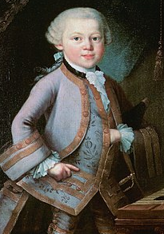
Focus pieces
Piano sonata K 331 Rondo alla Turca- Wolfgang Amadeus Mozart
Fur Elise- Ludvig van Beethoven

Interrelated Dimensions of Music
Discriminate between loud and soft; gradually increasing and decreasing volume.
Understand that melody can move up and down.

Other pieces we will be studying
My Grandfather’s clock
The Runaway train
The Quartermaster’s stores

Timeline
Mozart and Beethoven both lived in the period of music that we call the classical era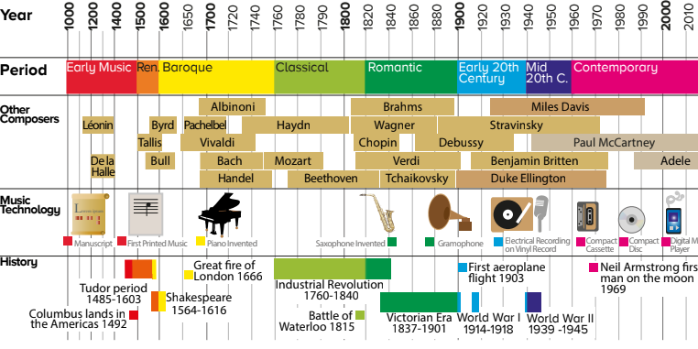

Key Vocabulary
Dynamics -Loud and soft- introduce correct language-piano soft- forte-loud
Melody - A sequence of musical notes that is musically satisfying- a tune
Keyboard instruments - Piano, organ, harpsichord, synthesizers
Composer- Someone who writes music
Symphony - An elaborate musical composition for full orchestra, typically in four movements, at least one of which is traditionally in sonata form
Sonata -A composition for an instrumental soloist, often with a piano accompaniment, typically in several movements with one or more in sonata form.
Opera -A dramatic work in one or more acts, set to music for singers and instrumentalists.

Useful websites
www.singup.org
Singing Sherlock by Val Whitlock and Shirley Court
The Usbourne’s Children’s Songbook edited by Anthony Marks
The National Songbook: Fifty Great songs for Children to Sing!

Sources of planning
National Curriculum, Civitas Core Knowledge

