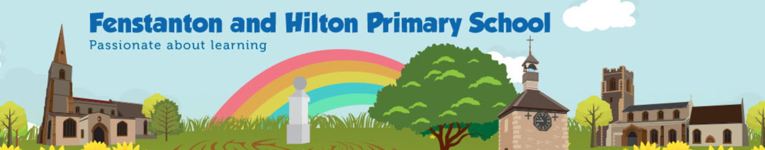
Knowledge Organiser

MUSIC | Djembe Drum Course EYFS SPRING 1
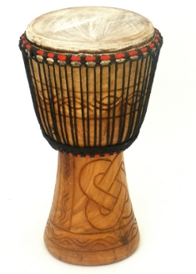

The djembe( pronounced Jem-bay) is one of West Africa's best known instruments. This goblet-shaped drum is traditionally carved from a single piece of African hardwood and topped with an animal skin as a drumhead. ... "Dje" means gather and "be" means everyone, which gave the drum used in these calls to order its name.
Origins and Traditions
- Africa is a continent NOT a country.
- 50 different countries make up Africa with many cultures.
- Djembe drums represent 10% of the entire population of Africa in terms of instruments they play.
- Invented in 1200 AD by the Mandinka Tribe from Mali.
Traditionally used for :-
- Passing on important historical, religious and cultural information to future generations by a Griot.
- Story telling
- Singing and dancing used as part of performances at events such as festivals, calling for rain or a good harvest, ceremonies like births, weddings and funerals.
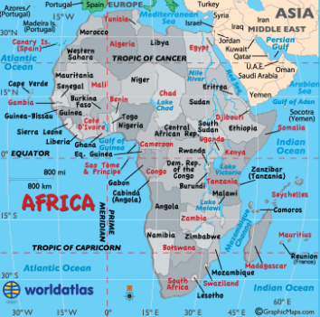
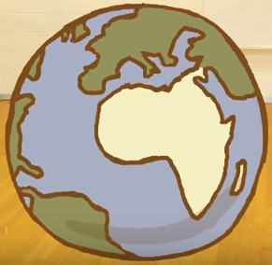

Related Instruments
Goblet Drum Dunun Ashiko Bougarabou
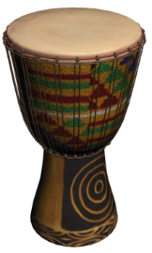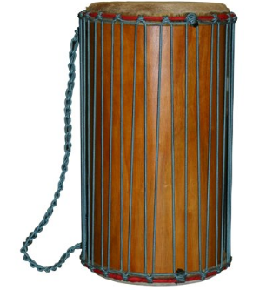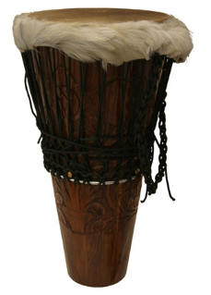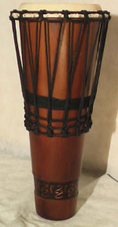

Key Vocabulary
Griot - A West African historian, story teller, praise singer, poet or musician.
Membranophone -A family of instruments in which the sound is produced by a stretched membrane.
Djembefola - A master djembe player.
Pitch - The quality of a sound governed by the rate of vibrations producing it.
Bass - Low pitch
Tone -Medium pitch
Slap- High pitch

Master Djembe players
Mamady Keita
Famoudou Konate

Useful resources
Albums worth listening to for an introductory overview of West African music :-
Mamady Keita: Wassolon, Nankama
Soungalo Coulibaly : L’ Art du Djembe
Sources of planning
National Curriculum,African percussionist Farai Malianga, YouTube

